March 30, 2023 – Java Project – Thea Gregory 5291240

Today I worked on the following:

* Created the views for the delivery guy menu
* Created the views for the manager

I am not particularly happy with my progress today. I’m tired and it is getting difficult to focus. There remains much left to do, but I need to be mindful that most of what’s left is basically identical to what I’ve already done. I think I can still finish. Last night I was very productive, completing order and most of Order History.

**Screenshots**:

Preparing an order:

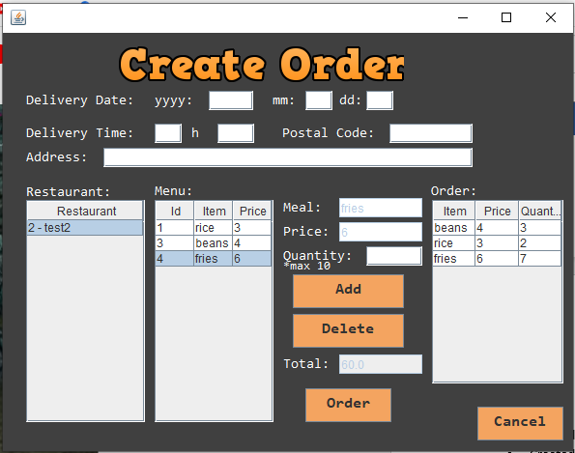

Confirmation (oops I found a bug):

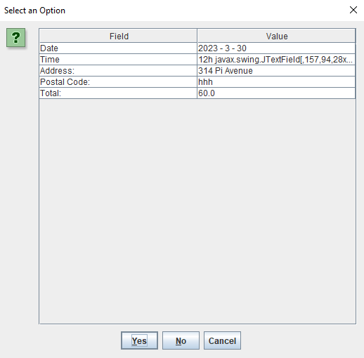

Order History (work in progress):

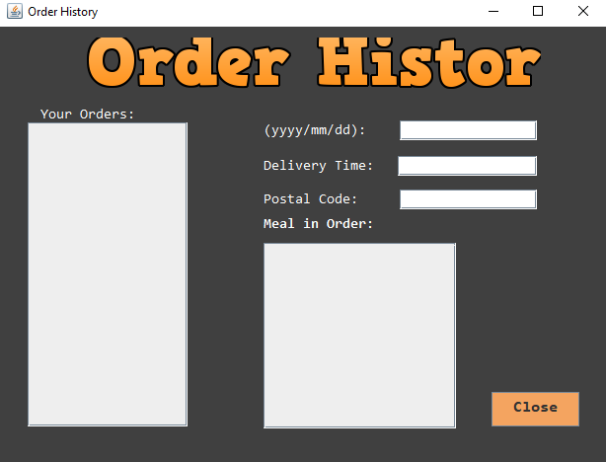

Accept Delivery prototype:

